Toddler Needs and Service Plan
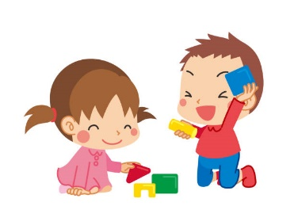
Child’s name: ________________________________ Date of birth: _______________
Parent name:_______________________________ Phone:_____________________
Parent name:________________________________ Phone:_____________________
Siblings & Ages:______________________________________________________________
Are there any known allergies or illnesses?________________________________________
Do you have any specific care instructions we need to be aware of?_________________________________
________________________________________________________________________________________

Feeding:
Does your child eat: Purees/Baby Food Solids
Can your child drink from: Sippy Cup Straw Cup Open Cup
Please describe your usual feeding schedule:
________________________________________________________________________________________
________________________________________________________________________________________
________________________________________________________________________________________

Are there any foods your child cannot have? What type? Why?
________________________________________________________________________________________

Sleeping:
How long does your child’s naps typically last?__________________________________________________

Describe their typical going to sleep routine:____________________________________________________
________________________________________________________________________________________

Is there anything we should know about your child’s sleep habits?___________________________________
_________________________________________________________________________________________

Does your child use a pacifier? Yes No
When do they usually need their pacifier?
_________________________________________________________________________________________

What soothing techniques are used when your child is upset? (ex: pacifier; holding…)
_________________________________________________________________________________________

Diapering:
What type of diapers does your child use? Disposable Diapers Cloth Diapers
What type of diaper ointment or cream does your child use?________________________________________
When would you like us to apply diaper cream?___________________________________________________

Cognitive:
What is your child’s general mood? Happy/Content Fussy Quiet Outgoing Other __________

Are there any concerns about your child’s health or behavior?
__________________________________________________________________________________________

Do you have any cultural traditions or practices you would like us to know about?________________________
__________________________________________________________________________________________

Parent Signature______________________________________ Date:________________

